Project Title
Full Stack Expense Tracker Application

1. Project Overview
This project is a Full Stack Expense Tracker Application developed using React.js, Node.js, Express.js, and MongoDB. The application helps users manage their daily income and expenses by recording transactions, categorizing spending, applying filters, and visualizing financial data using charts and graphs. It demonstrates practical implementation of authentication, CRUD operations, and data visualization in a MERN stack environment.

2. Objectives of the Project
- To build a real-world personal finance management system
- To implement secure user authentication using JWT
- To perform CRUD operations for income and expense transactions
- To categorize and filter financial data efficiently
- To visualize expenses using charts and graphs
- To follow industry-standard project structure and coding practices

3. Technology Stack

Frontend
- React.js
- Context API (Auth & Transaction Management)
- Chart Library (Chart.js / Recharts)
- CSS

Backend
- Node.js
- Express.js
- RESTful APIs

Database
- MongoDB
- Mongoose

4.Project Architecture
The application follows a Client–Server Architecture:
- Frontend (React) handles user interface and state management
- Backend (Node + Express) manages authentication and APIs
- MongoDB stores users and transaction data securely

5. Core Features
- JWT-based user authentication (Login / Register)
- Add, edit, and delete income & expense transactions
- Category-wise expense management (Food, Rent, Travel, Shopping, Salary, etc.)
- Filter transactions by date, category, and type
- Graphical analysis using charts (monthly trends, category-wise pie charts)

6. Functional Modules

6.1 User Authentication Module
- User registration and login
- Secure JWT token-based authentication
- Protected routes

6.2 Transaction Management Module
- Add income and expense records
- Edit and delete transactions
- Categorization of transactions

6.3 Filter & Analytics Module
- Filter by date range, category, and transaction type
- Monthly expense summary
- Visual charts and graphs

7. Project Directory Structure

Backend Structure
expense-tracker/
├── backend/
│ ├── src/
│ │ ├── config/
│ │ │ └── db.js
│ │ ├── models/
│ │ │ ├── User.js
│ │ │ └── Transaction.js
│ │ ├── controllers/
│ │ │ ├── authController.js
│ │ │ └── transactionController.js
│ │ ├── routes/
│ │ │ ├── authRoutes.js
│ │ │ └── transactionRoutes.js
│ │ ├── middleware/
│ │ │ ├── authMiddleware.js
│ │ │ └── errorMiddleware.js
│ │ └── server.js
│ ├── package.json
│ └── .env

Frontend Structure
frontend/
├── src/
│ ├── api/
│ │ ├── authApi.js
│ │ └── transactionApi.js
│ ├── components/
│ │ ├── Navbar.jsx
│ │ ├── TransactionForm.jsx
│ │ ├── TransactionList.jsx
│ │ └── ChartSection.jsx
│ ├── context/
│ │ ├── AuthContext.jsx
│ │ └── TransactionContext.jsx
│ ├── pages/
│ │ ├── Login.jsx
│ │ ├── Register.jsx
│ │ └── Dashboard.jsx
│ ├── styles/
│ │ └── app.css
│ ├── App.jsx
│ └── main.jsx
├── package.json

9. User Interface Description

Login & Register Page
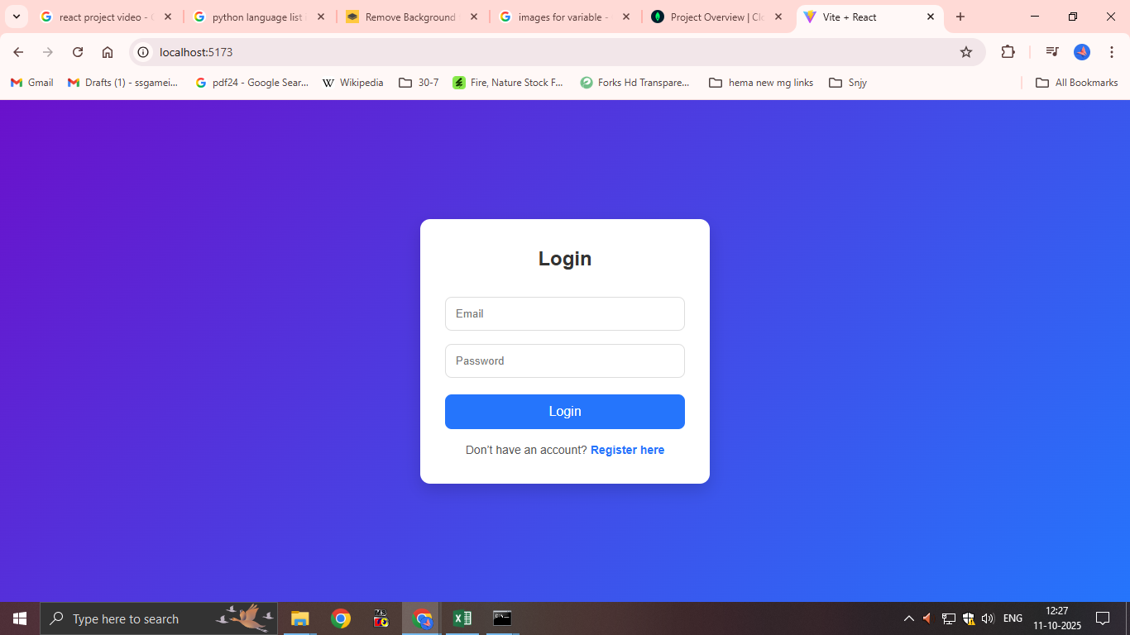
- Secure user authentication forms
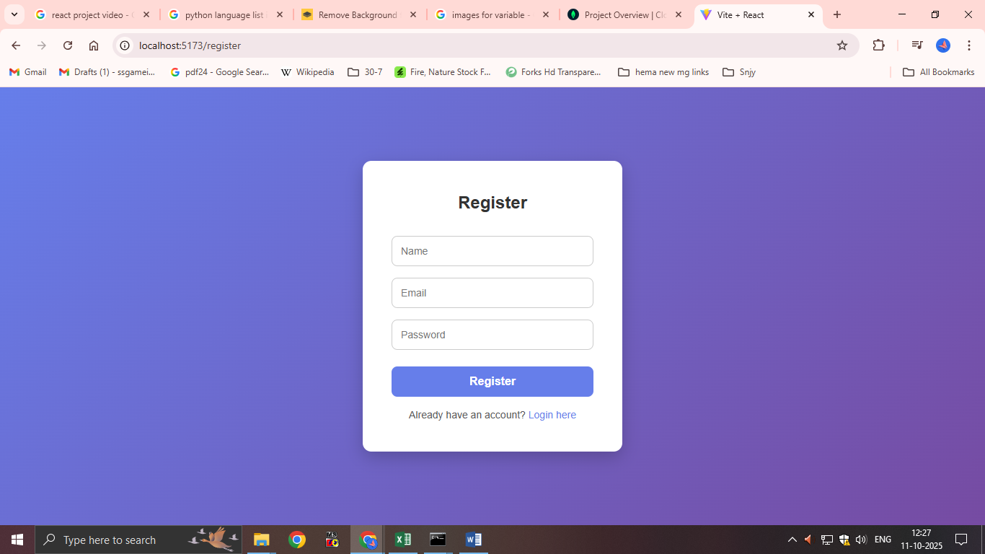

Dashboard Page
- Overview of income and expenses
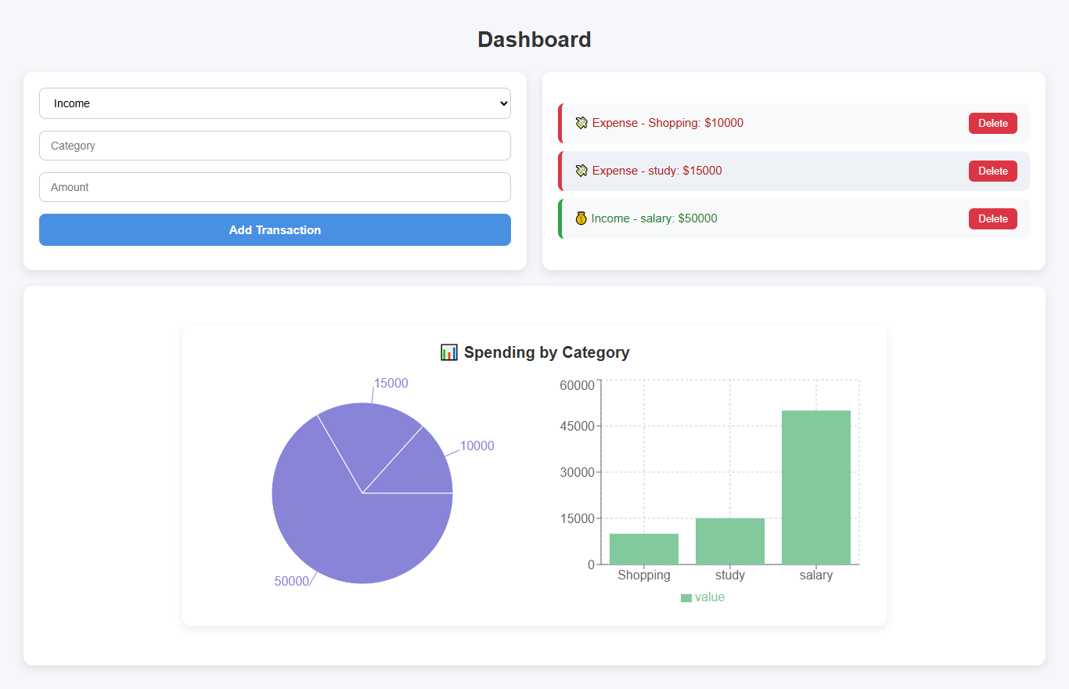
- Charts and graphs for financial analysis

10. Security & Validation
- JWT-based authentication
- Protected API routes
- Input validation on frontend & backend
- Environment variables for sensitive credentials

